CONFIDENTIAL  CS/NOV 2026/ICT450

UNIVERSITI TEKNOLOGI MARA
MARKING SCHEME

COURSE :
COURSE CODE :
EXAMINATION :
TIME :
DATABASE DESIGN AND DEVELOPMENT
ICT450
NOVEMBER 2026 (MOCK)
3 HOURS

MARKING SCHEME NOTES

- This marking scheme accompanies the ICT450 mock paper (November 2026).
Answers are unofficial model answers, not official UTM marking schemes.

- Marking points state the expected answer and the allocation of marks; every question retains its source paper and page reference.

- Five questions x 20 marks; total = 100 marks.
- Real-bank questions: 5. Placeholders: 0.
Questions and answers are for local study use only.

- Structure derived from 12 unique ICT450 past papers; every real question remains traceable to its source page.

FOR MARKERS' USE ONLY

This marking scheme consists of 7 printed pages.
MARKING GUIDE
QUESTION 1 (20 marks)
Source: ICT450-2024-JAN · page [2] · bank id ICT450-2024-JAN-Q1
Reference answer
(a) Meaning of data and database. [4 marks]
• Data are raw facts, such as a customer name or an order amount, that have not yet been processed into meaning.
• A database is an organised collection of logically related data stored and managed as a single repository.
(b) Data inconsistency and an example. [4 marks]
• Data inconsistency exists when the same fact has different values in different places.
• Example: a customer's phone number is updated in the Customers table but the old number remains in an Orders table.
(c) Zinnirah's problem and the ERD solution. [6 marks]
• The three tables are not linked by keys, so joins become complex and the same customer/product data is duplicated.
• The solution is an ERD with CUSTOMER, ORDER, PRODUCT and ORDER_LINE, where ORDER_LINE resolves the many-to-many order-product relationship.
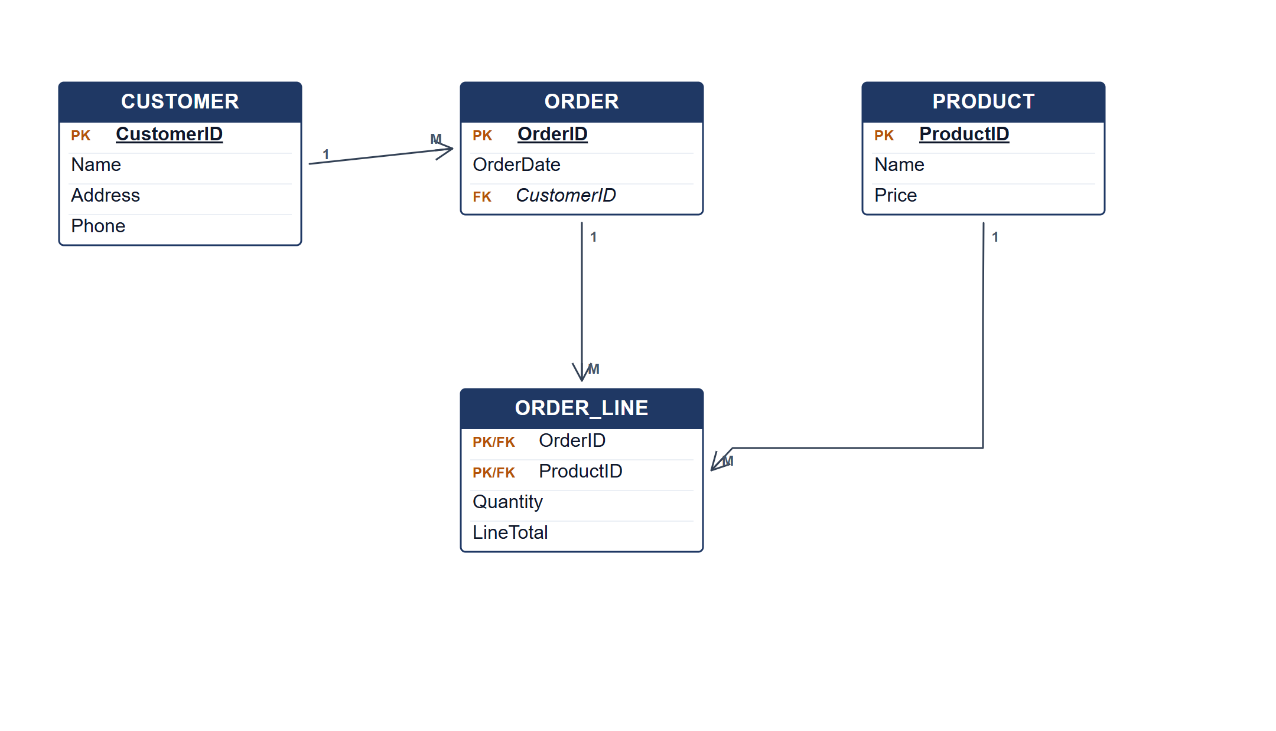
ERD for the ZY Stationary database.
(d) Three types of SDLC maintenance. [6 marks]
• Corrective maintenance — fixing errors found after delivery.
• Adaptive maintenance — changing the system for a new environment, platform or business rule.
• Perfective maintenance — improving performance or adding enhancements requested by users.
Marking guide
• a) 2 marks each for data and database (4).
• b) 2 marks for the definition and 2 for the example (4).
• c) 2 marks for the problem and 4 marks for the ERD (6).
• d) 2 marks for each maintenance type (6).
Provenance: model_unofficial · confidence high · Model-authored from the approved question text, the supplied source assets and the ICT200/ICT450 knowledge base; no official ICT450 marking scheme was supplied.
Knowledge base basis: TOPIC 1 DATABASE CONCEPT (1).pdf; TOPIC 2 DATA MODEL (1).pdf; TOPIC 3 RELATIONAL DATA MODELstu.pdf
Assumptions / notes
• The three tables are Customers, Orders and Products; an order can contain many products.

QUESTION 2 (20 marks)
Source: ICT450-2023-JUL · page [2] · bank id ICT450-2023-JUL-Q2
Reference answer
(a) Four activities in the database design phase. [8 marks]
• Create the conceptual design — identify entities, attributes, relationships and business rules.
• Select the DBMS software — choose a platform that fits the data model, cost and hardware.
• Create the logical design — map the conceptual model to tables, keys, domains and constraints.
• Create the physical design — choose storage, indexes, file organisation and access paths.
(b) Mobile database suitability and three usage factors. [8 marks]
• Yes, a mobile database is suitable for a company with branches in Malaysia and Indonesia because staff need access away from the office.
• Factor 1: ubiquitous connectivity — field staff can reach the database from any branch or location.
• Factor 2: synchronization — local device data can be reconciled with the central database when connectivity returns.
• Factor 3: portability and location-aware services — mobile devices support on-site inventory and customer service.
(c) Structured versus unstructured data. [4 marks]
• Structured data has a predefined schema and is stored in rows and columns; example: a sales table.
• Unstructured data has no predefined relational schema; example: images, video, audio or free-text documents.
Marking guide
• a) 2 marks for each of four design activities (8).
• b) 2 marks for suitability and 2 marks for each of three factors (2 + 6 = 8).
• c) 2 marks for each data type with example (4).
Provenance: model_unofficial · confidence high · Model-authored from the approved question text, the supplied source assets and the ICT200/ICT450 knowledge base; no official ICT450 marking scheme was supplied.
Knowledge base basis: TOPIC 2 DATA MODEL (1).pdf; TOPIC 6 DATABASE DESIGN (1).pdf

QUESTION 3 (20 marks)
Source: ICT450-2024-JUL · page [4] · bank id ICT450-2024-JUL-Q3
Reference answer
The Sasa eStore invoice contains a repeated item list and member data. It is flattened to one row per invoice line.
(a) Normal form of Figure 1. [3 marks]
• The invoice is in 1NF when flattened to one row per item; all values are atomic.
• It is not in 2NF because member details depend on MemberID, while item price depends on ItemName, not on the full invoice key.
• It is not in 3NF because MemberName and Address depend transitively on MemberID, and totals are repeated.
(b) Primary key and dependencies. [6 marks]
Flattened invoice relation.
INVOICE (InvoiceNo, InvoiceDate, MemberID, MemberName, Address, ItemName, Quantity, UnitPrice, Amount, Total, PaidAmount, BalanceDue)
Functional dependencies.
InvoiceNo → InvoiceDate, MemberID, Total, PaidAmount, BalanceDue
MemberID → MemberName, Address
ItemName → UnitPrice
InvoiceNo, ItemName → Quantity, Amount
(c) Normalise from 1NF to 3NF. [11 marks]
1NF: one row per invoice item; key (InvoiceNo, ItemName).
2NF: remove partial dependencies.
2NF relations.
INVOICE (InvoiceNo, InvoiceDate, MemberID, MemberName, Address, Total, PaidAmount, BalanceDue)
ITEM (ItemName, UnitPrice)
INVOICE_ITEM (InvoiceNo, ItemName, Quantity, Amount)
3NF: remove MemberID → MemberName/Address.
3NF relations.
MEMBER (MemberID, MemberName, Address)
INVOICE (InvoiceNo, InvoiceDate, MemberID, Total, PaidAmount, BalanceDue)
ITEM (ItemName, UnitPrice)
INVOICE_ITEM (InvoiceNo, ItemName, Quantity, Amount)
Sample 3NF data: ITEM
ItemName | UnitPrice
Green Deep Lip & Eye Remover | 65.00
Argan Oil Cleansing Foam | 49.00
10% Niacinamide Serum | 56.00

Marking guide
• a) 3 marks: 1NF plus 2NF/3NF reasons.
• b) 6 marks: key (2), dependencies (4).
• c) 11 marks: 1NF (2), 2NF (4), 3NF (5).
Provenance: model_unofficial · confidence high · Model-authored from the approved question text, the supplied source assets and the ICT200/ICT450 knowledge base; no official ICT450 marking scheme was supplied.
Knowledge base basis: TOPIC 5 NORMALIZATION (1).pdf
Assumptions / notes
• The invoice has no printed item ID; ItemName is treated as the product identifier. The duplicate Argan Oil line is a repeated purchase line.

QUESTION 4 (20 marks)
Source: ICT450-2025-FEB · page [4] · bank id ICT450-2025-FEB-Q4
Reference answer
e-Travel schema.
CUSTOMERS (CustomerID, FirstName, LastName, PhoneNumber)
BOOKING (BookingID, BookingDate, NumberOfPax, TripDate, CustomerID*, GuideID*, PackageID*)
GUIDE (GuideID, GuideName, BasicSalary, HireDate)
PACKAGE (PackageID, PackageName, PricePerPax, PackageDetails)
(a) Total number of trips for each date. [4 marks]
SELECT TripDate, COUNT(*) AS total_trips
FROM BOOKING
GROUP BY TripDate;
(b) Customer with the highest number of bookings. [4 marks]
SELECT c.*
FROM CUSTOMERS c
JOIN BOOKING b ON b.CustomerID = c.CustomerID
GROUP BY c.CustomerID, c.FirstName, c.LastName, c.PhoneNumber
ORDER BY COUNT(*) DESC
FETCH FIRST 1 ROW ONLY;
(c) Increase 10% salary for guides on a February 2025 trip. [4 marks]
UPDATE GUIDE
SET BasicSalary = BasicSalary * 1.10
WHERE GuideID IN (
SELECT GuideID
FROM BOOKING
WHERE TripDate BETWEEN DATE '2025-02-01' AND DATE '2025-02-28'
);
(d) Packages booked more than 70 times. [4 marks]
SELECT p.PackageName
FROM PACKAGE p
JOIN BOOKING b ON b.PackageID = p.PackageID
GROUP BY p.PackageID, p.PackageName
HAVING COUNT(*) > 70;
(e) Customers who booked between February and March 2025. [4 marks]
SELECT COUNT(DISTINCT CustomerID) AS total_customers
FROM BOOKING
WHERE TripDate BETWEEN DATE '2025-02-01' AND DATE '2025-03-31';
Marking guide
• a) 4 marks: GROUP BY date and COUNT.
• b) 4 marks: join, GROUP BY customer, descending order/top-1.
• c) 4 marks: UPDATE, 10%, February subquery.
• d) 4 marks: join, GROUP BY package, HAVING > 70.
• e) 4 marks: COUNT DISTINCT and date range.
Provenance: model_unofficial · confidence high · Model-authored from the approved question text, the supplied source assets and the ICT200/ICT450 knowledge base; no official ICT450 marking scheme was supplied.
Knowledge base basis: TOPIC 7 SQL.pdf
Assumptions / notes
• TripDate is the date used for the February/March filters.

QUESTION 5 (20 marks)
Source: ICT450-2025-JUL · page [5, 6] · bank id ICT450-2025-JUL-Q5
Reference answer
The ERD models collectors, duties, localities, vehicles, houses and waste types. The supervisor relationship is recursive on COLLECTOR, and DUTY_WASTE records the weight collected for each waste type.
(a) Construct the ERD with Crow's Foot notation. [16 marks]
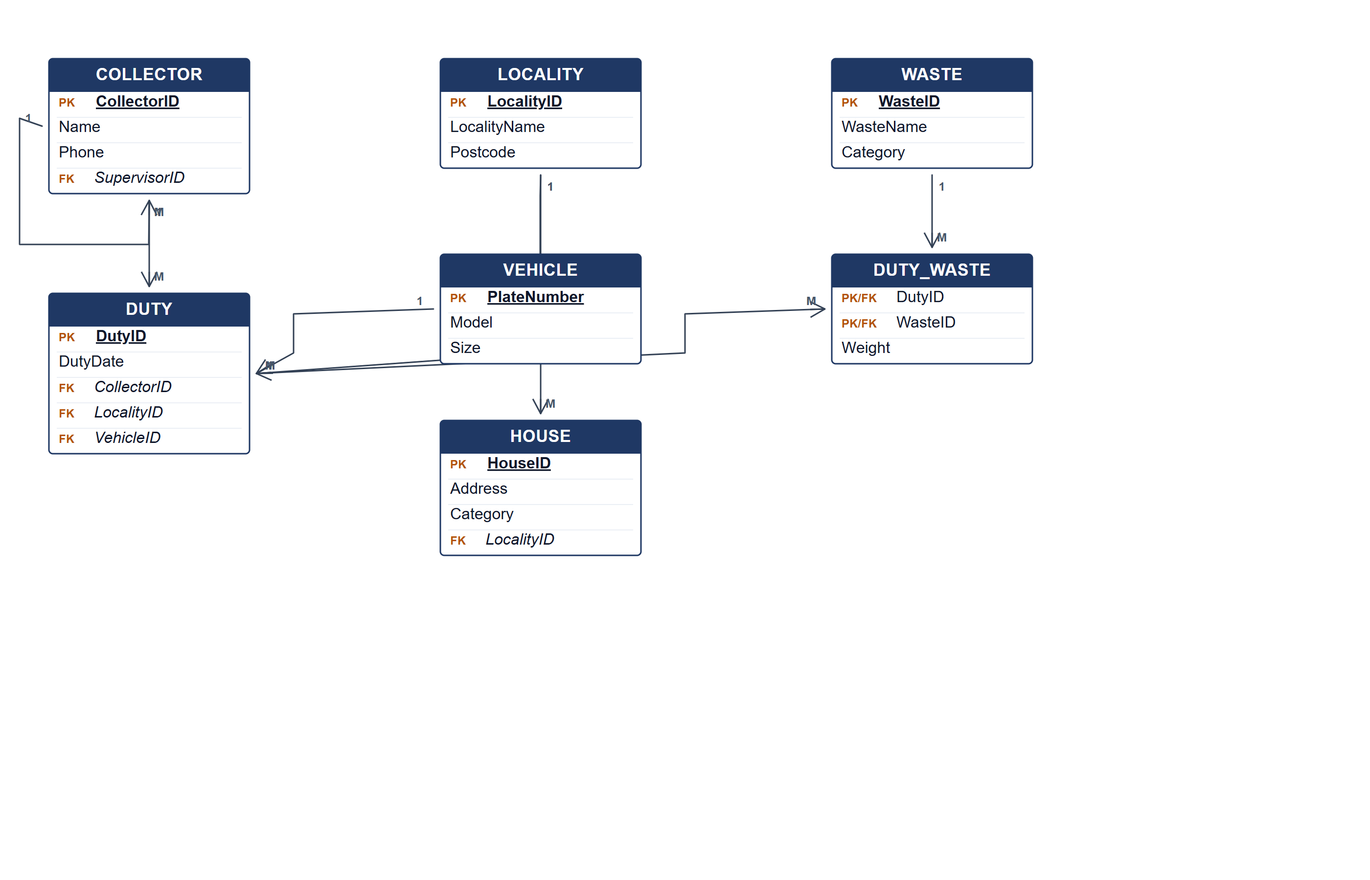
Clean Environment ERD.
(b) Two pieces of information from the ERD. [4 marks]
• The collection duties assigned to each collector, with date, locality and vehicle.
• The total weight collected for each waste type and locality.
Marking guide
• a) 16 marks: collector/duty/locality/vehicle (6); house and waste (4); recursive supervisor and DUTY_WASTE relationships (4); keys (2).
• b) 2 marks for each information item (4).
Provenance: model_unofficial · confidence medium · Model-authored from the approved question text, the supplied source assets and the ICT200/ICT450 knowledge base; no official ICT450 marking scheme was supplied.
Knowledge base basis: TOPIC 4 ERD_stu (2).pdf; TOPIC 3 RELATIONAL DATA MODELstu.pdf
Assumptions / notes
• Supervisor is a recursive role on COLLECTOR; a duty collects many waste types with a weight per waste type.

